### **Part 1: Backpropagation in CNN - Conceptual Overview and Neural Network (NN) Part**

The focuses on **backpropagation in Convolutional Neural Networks (CNNs)**, a crucial and conceptually challenging topic in deep learning. The instructor notes the difficulty, particularly with the mathematics involved, and recommends watching the videos multiple times with pen and paper. Content on this specific topic is also scarce online and in textbooks.

### **1. Video Series Structure & Learning Approach**

* **Part 1 (Current Video)**: Overarching understanding of how **backpropagation applies to CNNs**.
* **Part 2 (Next Video)**: Detailed discussion on how backpropagation is applied to specific operations:
  + **Convolution operation**.
  + **Max Pooling**.
  + **Flatten layer**.
* **Part 3 (Last Video)**: Applying backpropagation to a **more complex CNN architecture**.

**Learning Advice**:

* Watch multiple times, if possible.
* Sit with copy and pen, as there will be significant mathematics.
* A deeper understanding of machine learning/deep learning principles helps in effectively using tools.

### **2. Simple CNN Architecture Example for Discussion**

To understand backpropagation, a simple CNN architecture is used as an example:

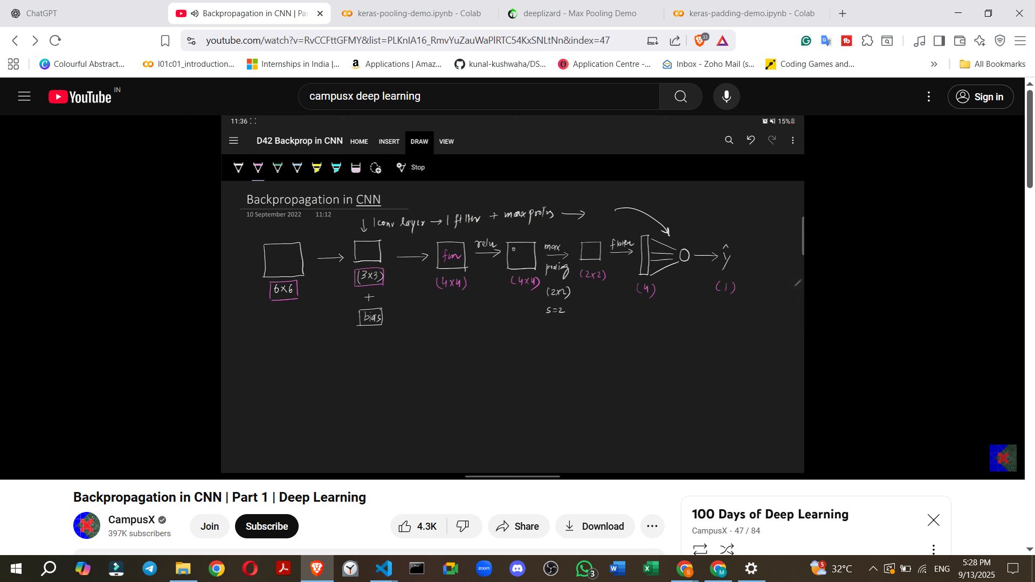

1. **Input**: An image (e.g., 6x6 pixels).
2. **Convolution Operation**: The image is passed through a **filter** (e.g., 3x3) which includes weights (W1) and a bias (b1). This produces **Z1**, a feature map.
3. **ReLU Activation**: A Rectified Linear Unit (ReLU) operation is applied to Z1, yielding **A1** (another feature map, but with negative values rectified to zero).
4. **Max Pooling**: A **Max Pooling** operation (e.g., 2x2 filter with a stride of 2) is applied to A1. This downsamples the feature map, resulting in **P1**.
5. **Flatten Layer**: The output P1 is **flattened** into a one-dimensional array, denoted as **F**.
6. **Output Neuron (Dense Layer)**: The flattened output **F** is fed into a single output neuron (a dense layer). This neuron calculates **Z2** (a dot product of F and weights W2, plus bias b2), then applies an activation (e.g., Sigmoid) to get **A2** (the prediction, or y-hat).
7. **Loss Calculation**: The prediction **A2** is used to calculate the **loss (L)** against the true label (Y).

### **3. Tensor Flow and Shape Changes**

It's crucial to visualize how the tensor shape changes throughout the architecture:

* **Initial Image**: 6x6.
* **After Convolution**: The feature map (Z1) becomes 4x4.
* **After ReLU**: The shape remains 4x4 (A1).
* **After Max Pooling**: The feature map (P1) becomes 2x2 (half the size due to 2x2 filter, stride 2).
* **After Flattening**: The 2x2 output becomes a 1D vector of length 4 (F).
* **Final Output**: A single scalar value (1x1) representing the prediction (A2).

### **4. Trainable Parameters in the Example CNN**

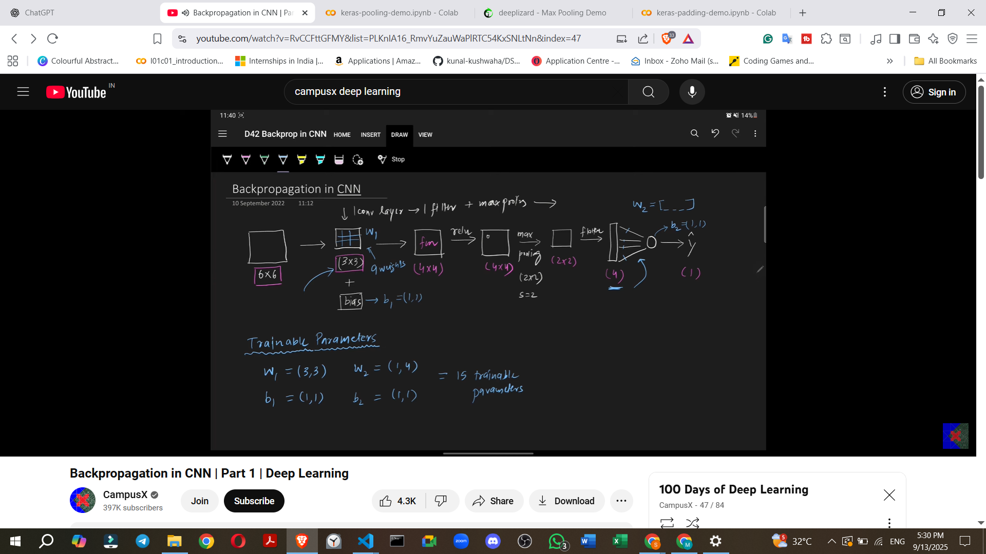

**Where are the trainable parameters?** There are only two locations with trainable parameters in this simple architecture:

1. **Convolution Filter**:
   * Weights (W1): A 3x3 filter, so **9 weights**.
   * Bias (b1): **1 bias**.
   * Total for W1, b1: 10 parameters.
2. **Output Neuron (Dense Layer)**:
   * Weights (W2): Since the flattened input (F) has 4 values, there are **4 weights** connecting to the single output neuron.
   * Bias (b2): **1 bias**.
   * Total for W2, b2: 5 parameters.

**Total Trainable Parameters**: 9 (W1) + 1 (b1) + 4 (W2) + 1 (b2) = **15 parameters**.

**Objective**: When training the CNN model using backpropagation, the goal is to find the **optimum values for these 15 parameters** that minimize the loss.

### **5. Loss Function**

* **Problem Type**: The example uses a **binary classification problem** (e.g., detecting if an image is a cat or a dog).
* **Loss Function**: The **Binary Cross-Entropy (BCE) loss** is used, similar to logistic regression.
  + **For a single instance**: L = -yi * log(y_hat) - (1 - yi) * log(1 - y_hat).
    - yi: The true label.
    - y_hat: The predicted probability (A2).
* **For a batch of images**: The **average loss** is calculated by summing the individual losses and dividing by the number of images (N).
* **Multiclass Classification**: For multi-class problems, **Softmax loss** would be used.

### **6. Logical Diagram of the CNN Architecture**

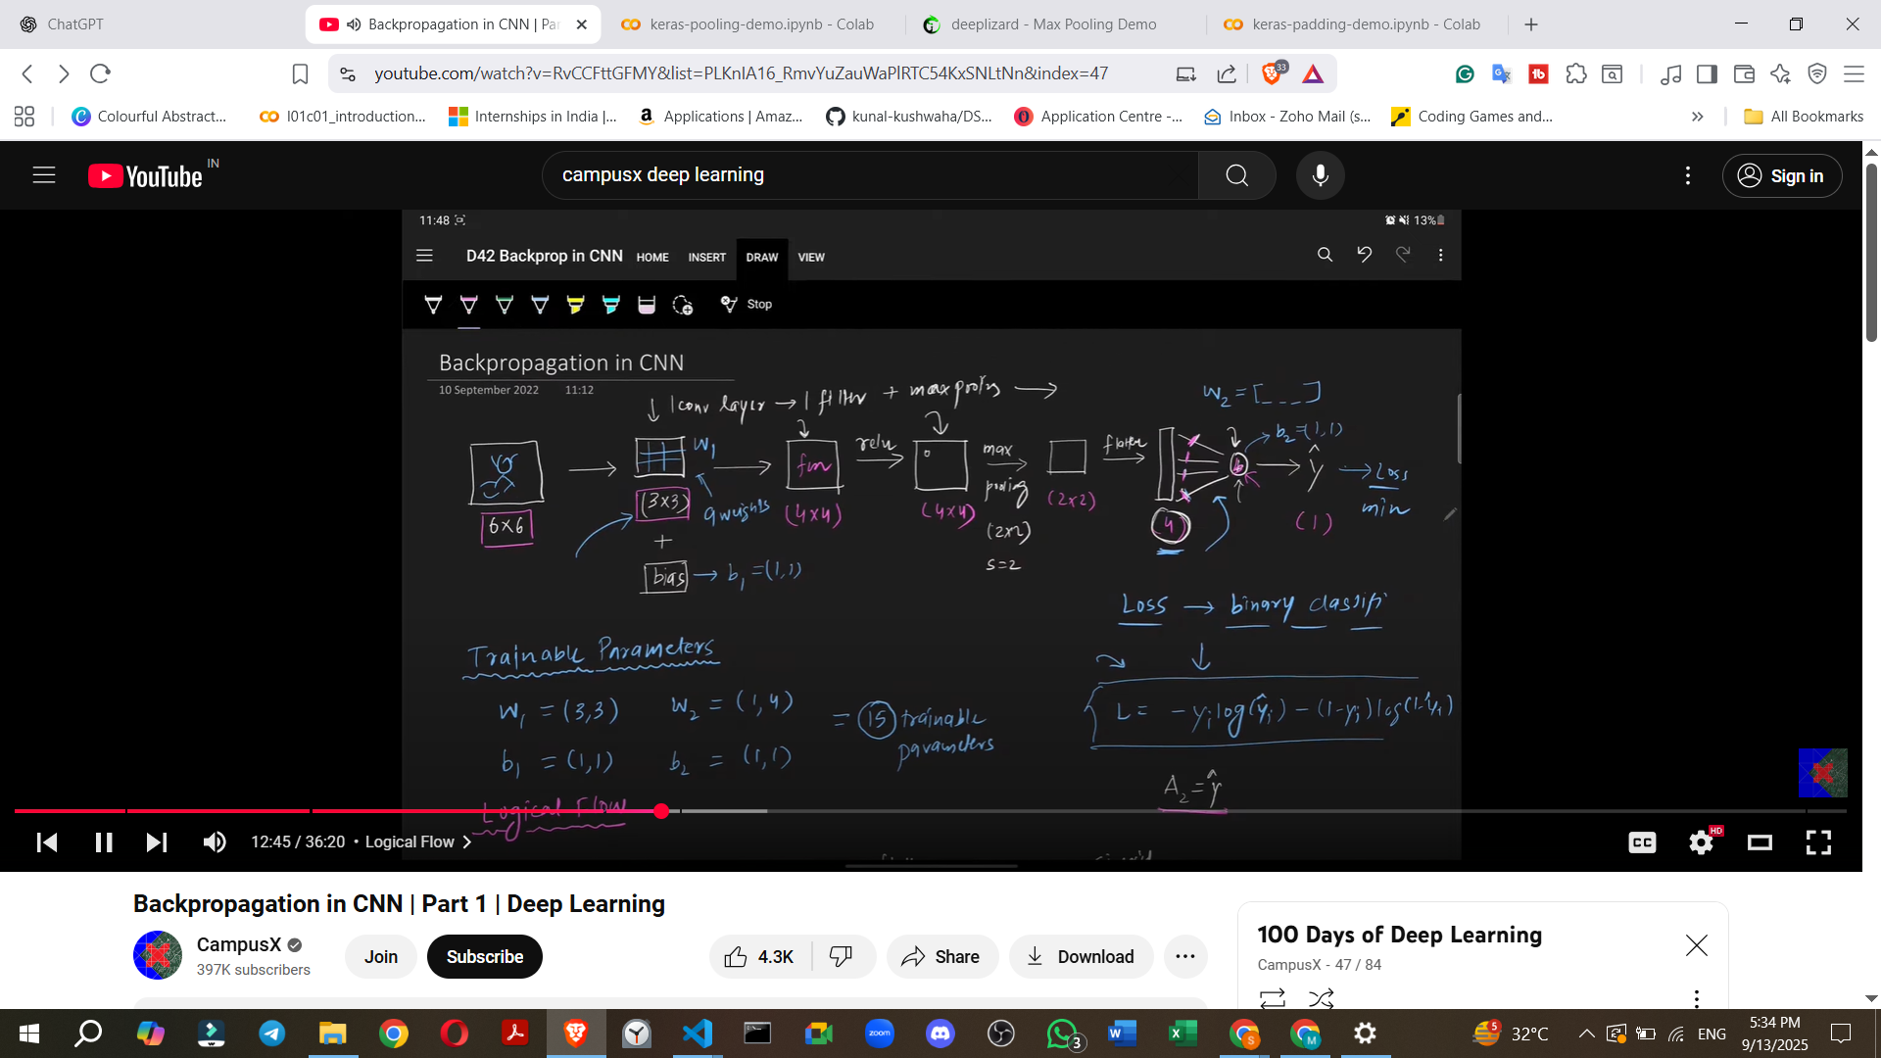

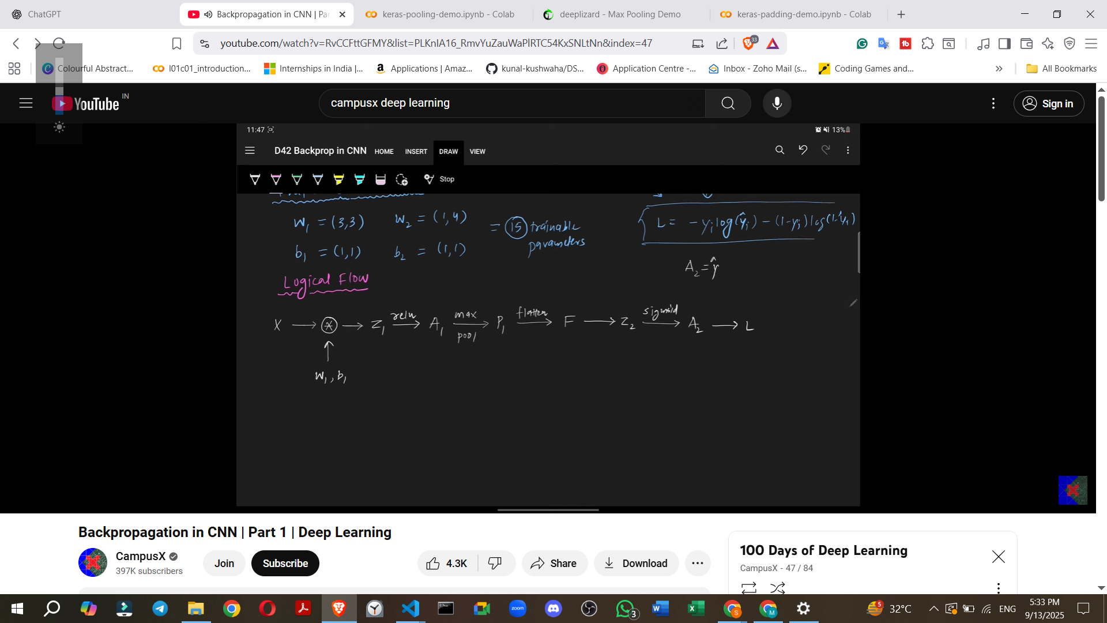

A logical diagram helps visualize the flow for backpropagation:

**X (Image)** ↓ **Convolution (W1, b1)** ↓ **Z1** ↓ **ReLU** ↓ **A1** ↓ **Max Pooling** ↓ **P1** ↓ **Flatten** ↓ **F** (Input to Dense Layer) ↓ **Z2** (F ⋅ W2 + b2) ↓ **A2** (Prediction / y_hat, via Sigmoid) ↓ **Loss (L)** (Calculated from A2 and true label Y)

**Recommendation**: It is advised to **draw this logical flow** to understand the process clearly.

### **7. Forward Propagation Equations (Rough)**

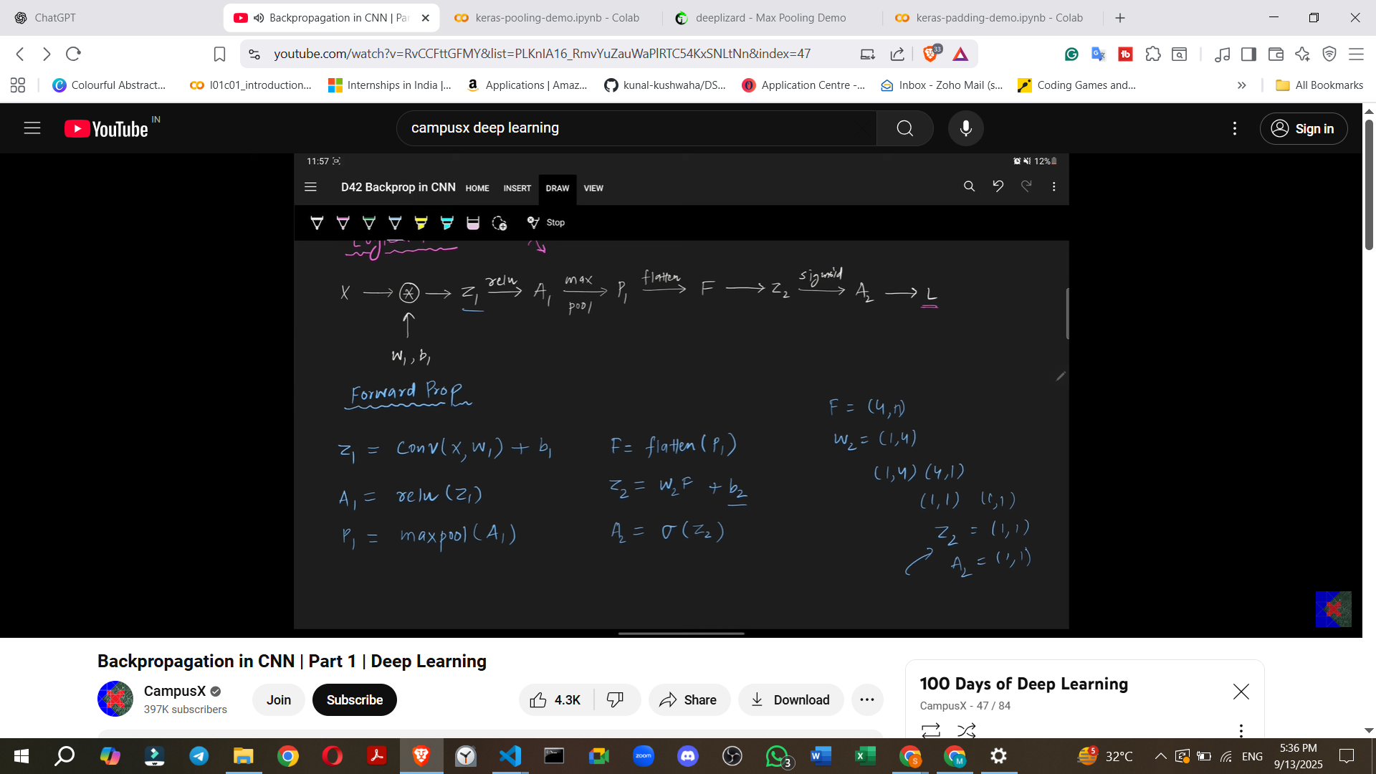

These equations represent the computation in the forward pass:

* Z1 = Convolution(X, W1) + b1
* A1 = ReLU(Z1)
* P1 = MaxPool(A1)
* F = Flatten(P1)
* Z2 = F ⋅ W2 + b2
* A2 = Sigmoid(Z2) (Implied, as A2 is a prediction in a binary classification context)
* L = Loss(A2, Y)

These equations form the basis for writing a program to predict output for a given image.

### **8. Backpropagation Goal: Gradient Calculation**

* **End Goal**: Apply a **gradient descent algorithm** to update the trainable parameters (W1, b1, W2, b2) until the **loss is minimized**.

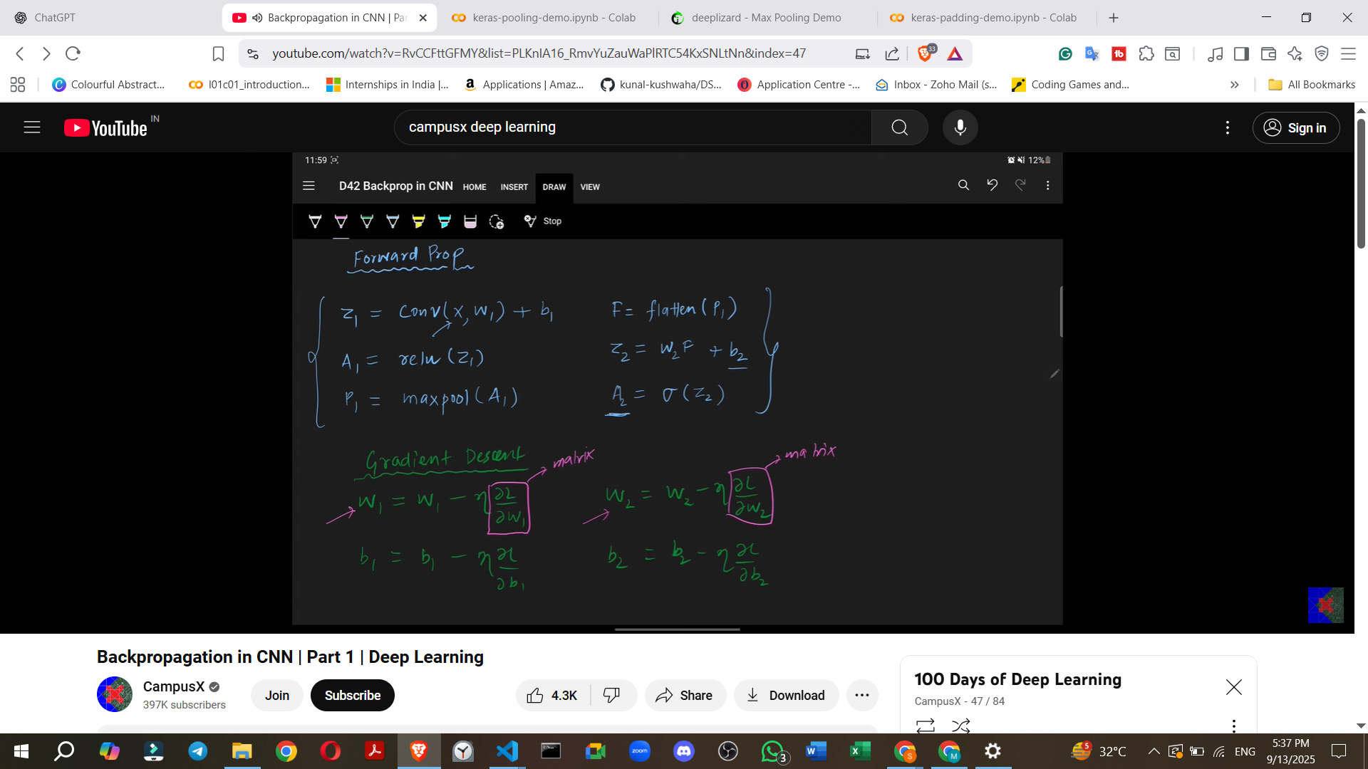

* **Core Task**: Calculate the **derivatives (gradients)** of the loss with respect to each trainable parameter:
  + dL/dW1
  + dL/db1
  + dL/dW2
  + dL/db2

**Note**: W1 and W2 are matrices/vectors, so their derivatives will also be matrices/vectors. These gradients guide the updates of randomly initialized parameter values.

### **9. Dividing the Architecture for Backpropagation Study**

To simplify the process, the CNN architecture is conceptually divided into two parts:

1. **Neural Network (NN) Part**: From the **Flatten layer to the output neuron and loss calculation**. This part will be covered in the current video.
2. **CNN Part**: The **Convolutional, ReLU, and Max Pooling layers**. This will be covered in subsequent videos.

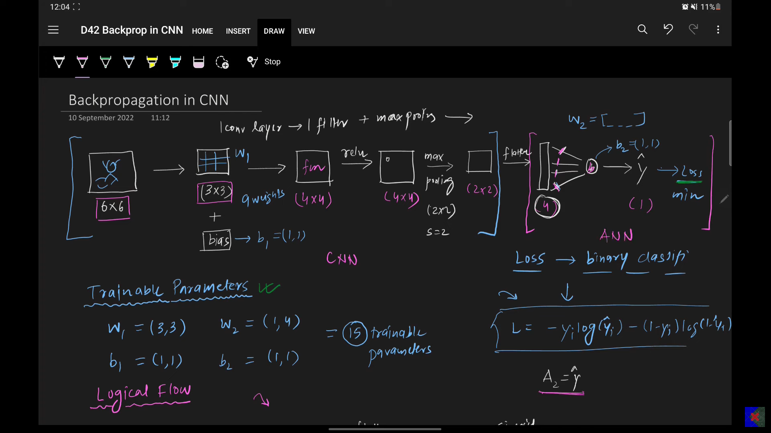

### **10. Calculating Gradients for the NN Part (dL/dW2 and dL/db2)**

Backpropagation starts from the loss and moves backward.

**Question**: How do we calculate dL/dW2 and dL/db2?

Using the **chain rule**, we trace how changes in W2 or b2 affect the loss L:

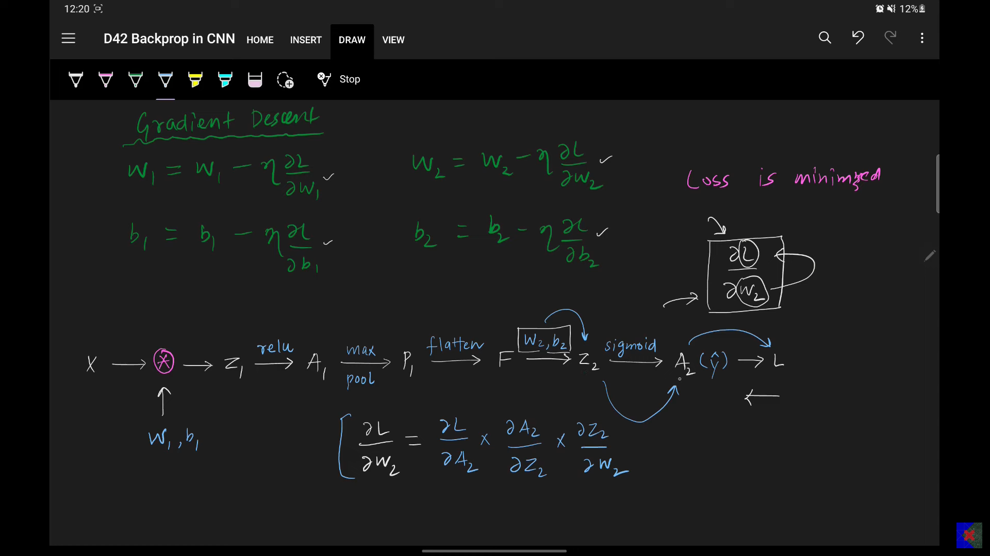

* dL/dW2 = (dL/dA2) * (dA2/dZ2) * (dZ2/dW2)
* dL/db2 = (dL/dA2) * (dA2/dZ2) * (dZ2/db2)

**Detailed Calculations for a Single Image (Scalar A2)**:

1. **dL/dA2 (Derivative of Loss with respect to Prediction)**:

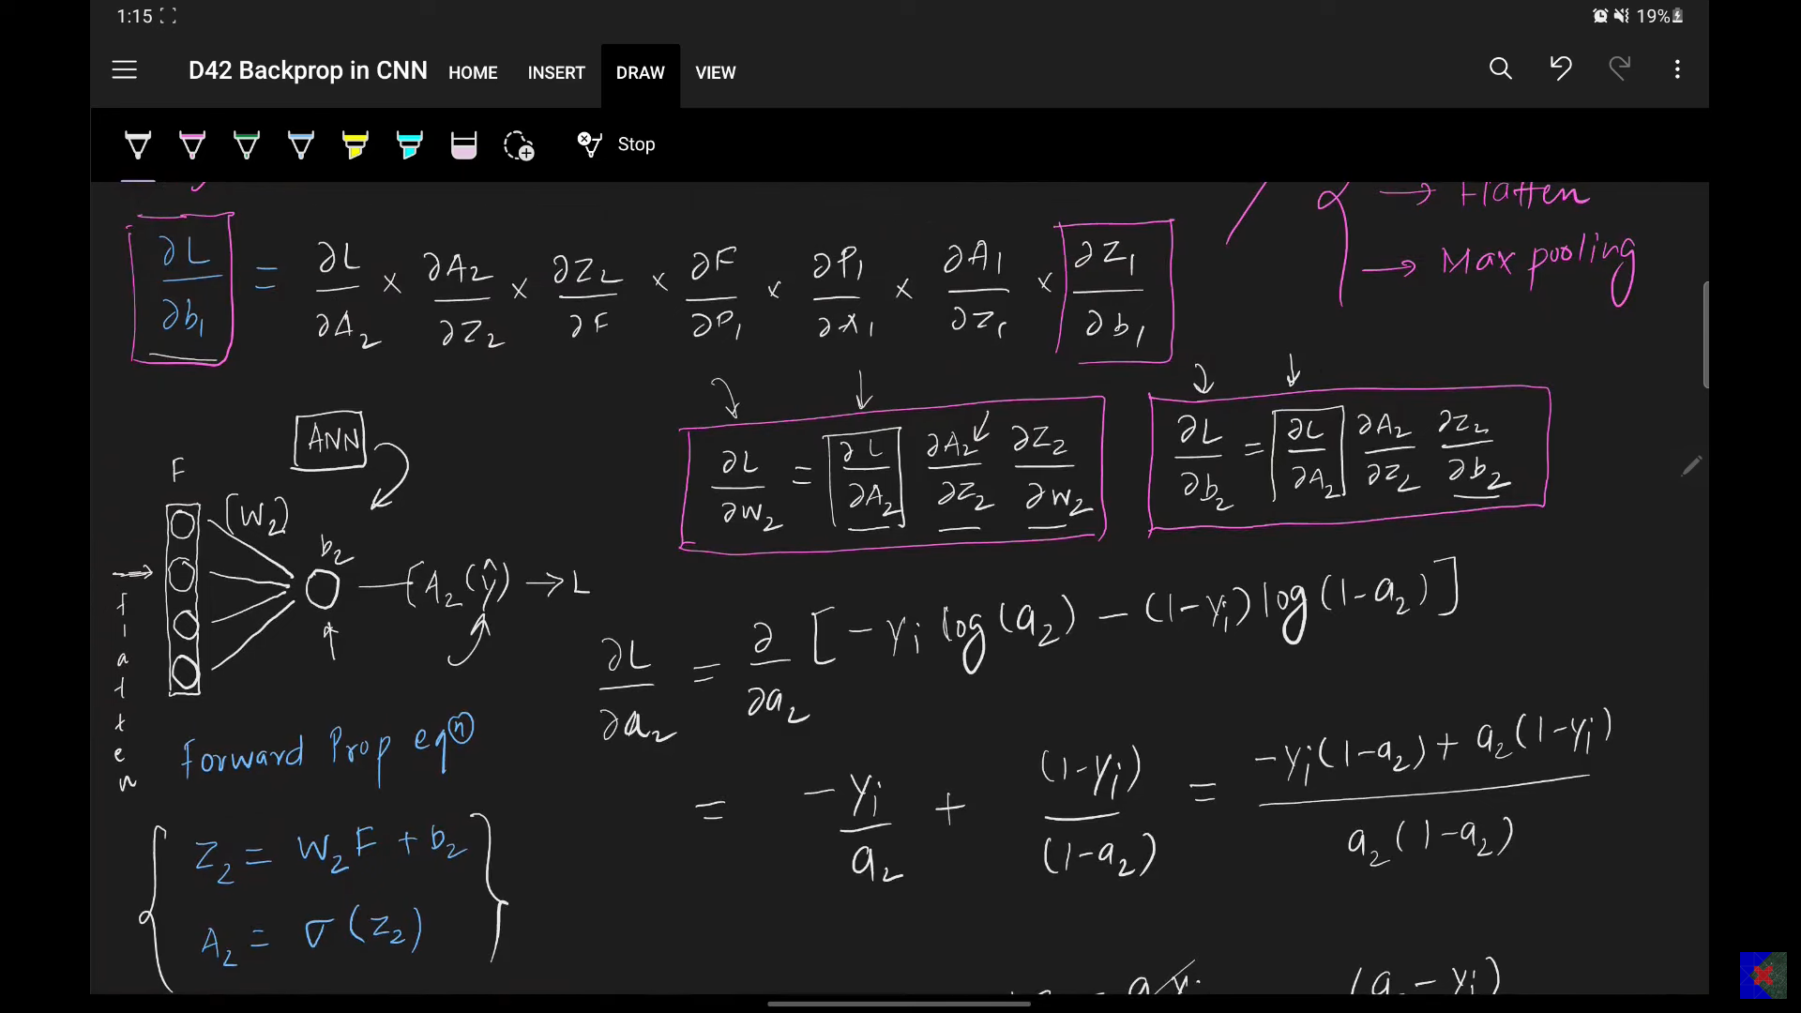

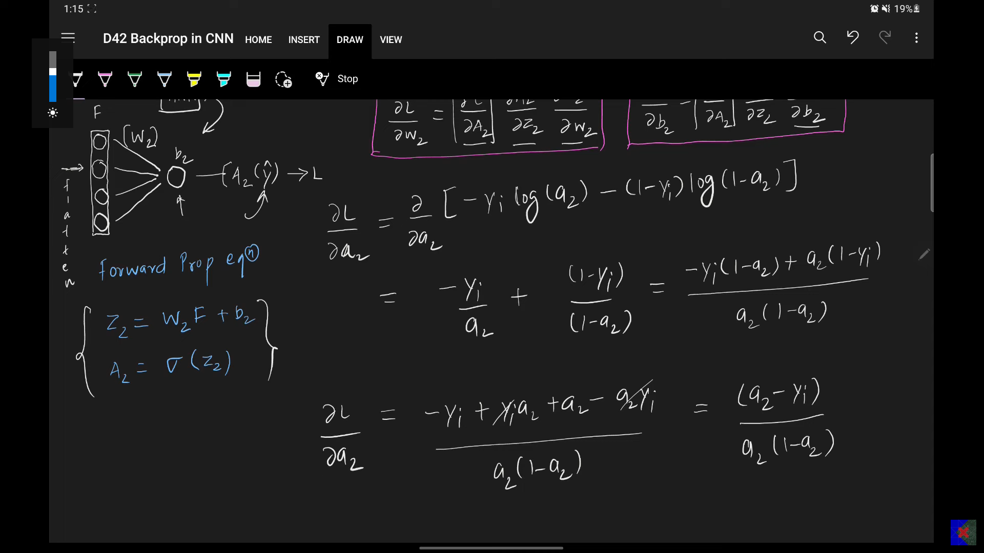

* + Assuming L = -y * log(A2) - (1 - y) * log(1 - A2).
  + dL/dA2 = (A2 - y) / (A2 * (1 - A2)).

1. **dA2/dZ2 (Derivative of Sigmoid Activation)**:

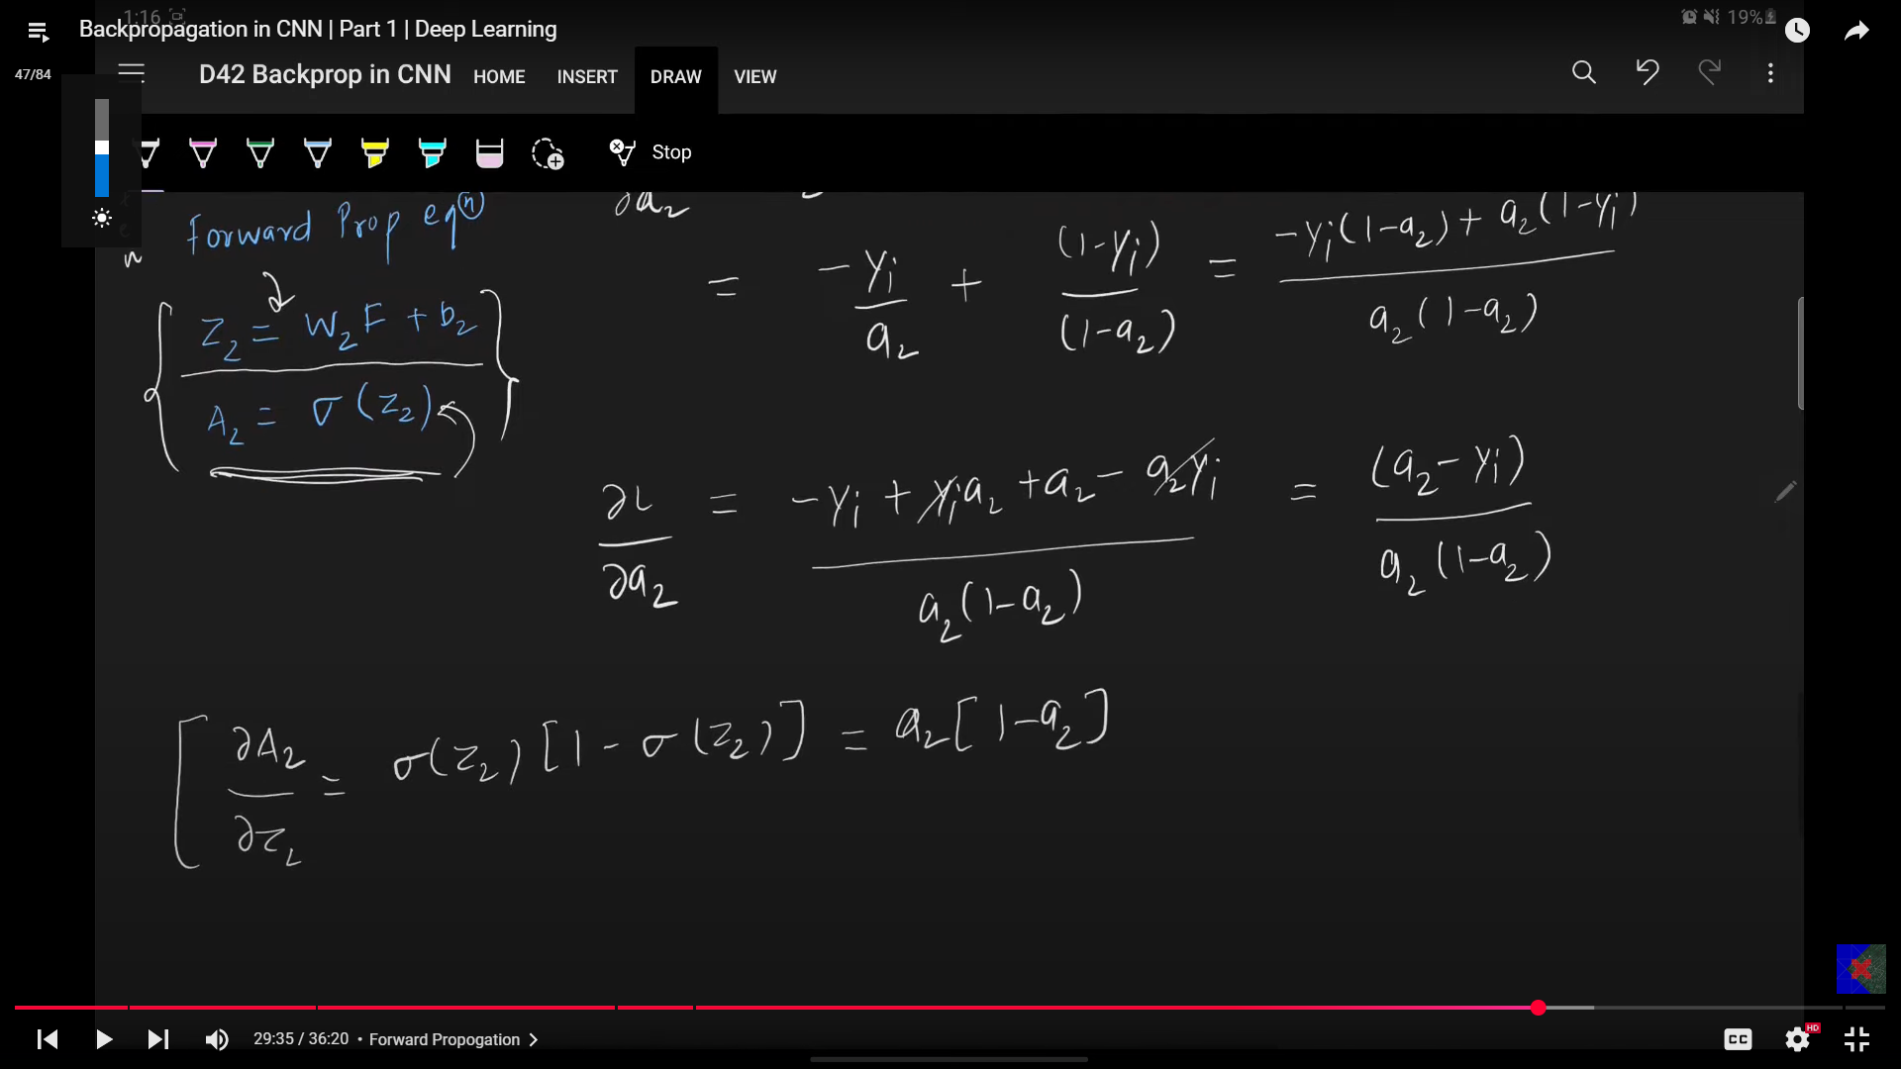

* + Assuming A2 = Sigmoid(Z2).
  + dA2/dZ2 = A2 * (1 - A2).

1. **dZ2/dW2 (Derivative of Z2 with respect to W2)**:

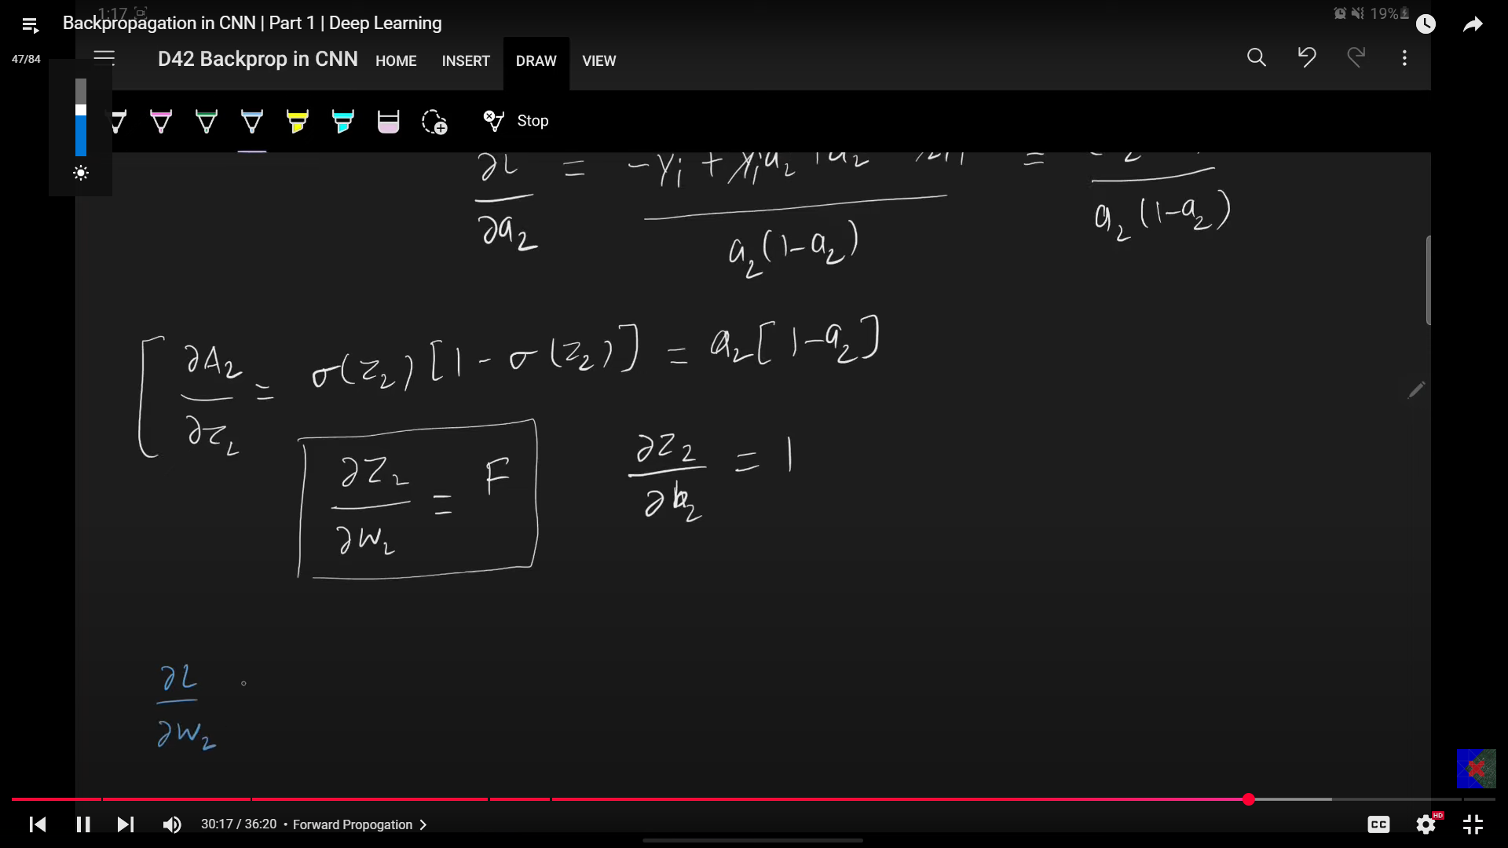

* + Recall Z2 = F ⋅ W2 + b2.
  + dZ2/dW2 = F (the input from the Flatten layer).

1. **dZ2/db2 (Derivative of Z2 with respect to b2)**:



* + Recall Z2 = F ⋅ W2 + b2.
  + dZ2/db2 = 1.

**Combining these derivatives**:

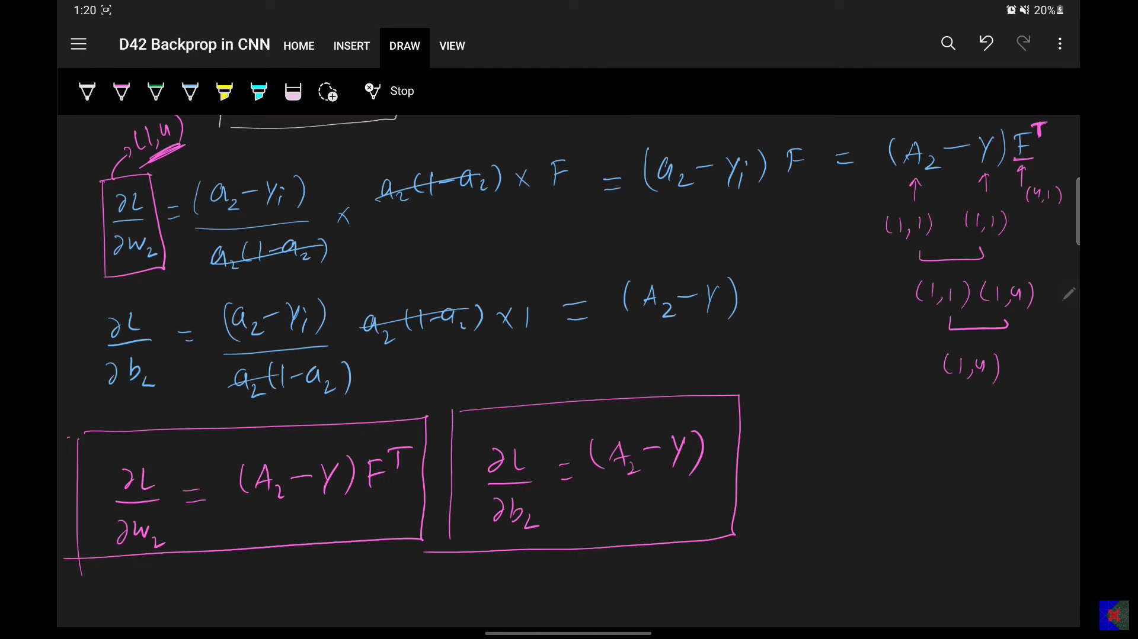

* **dL/dW2 Calculation**:  
  + dL/dW2 = [(A2 - y) / (A2 * (1 - A2))] * [A2 * (1 - A2)] * F
  + **dL/dW2 = (A2 - y) * F**.
* **dL/db2 Calculation**:



* + dL/db2 = [(A2 - y) / (A2 * (1 - A2))] * [A2 * (1 - A2)] * 1
  + **dL/db2 = A2 - y**.

**Shape Considerations for dL/dW2**:

* W2 has a shape of (1, 4) (one output neuron, four inputs).
* F has a shape of (4, 1) for a single image.
* (A2 - y) is a scalar (1, 1).
* To ensure dL/dW2 has the correct shape (1, 4) for updating W2, the multiplication of (A2 - y) and F should effectively result in (A2 - y) * F.T.



### **11. Gradients for the CNN Part (dL/dW1 and dL/db1)**

**Question**: How do we calculate dL/dW1 and dL/db1?

These calculations are more complex and involve backpropagating through the earlier layers:

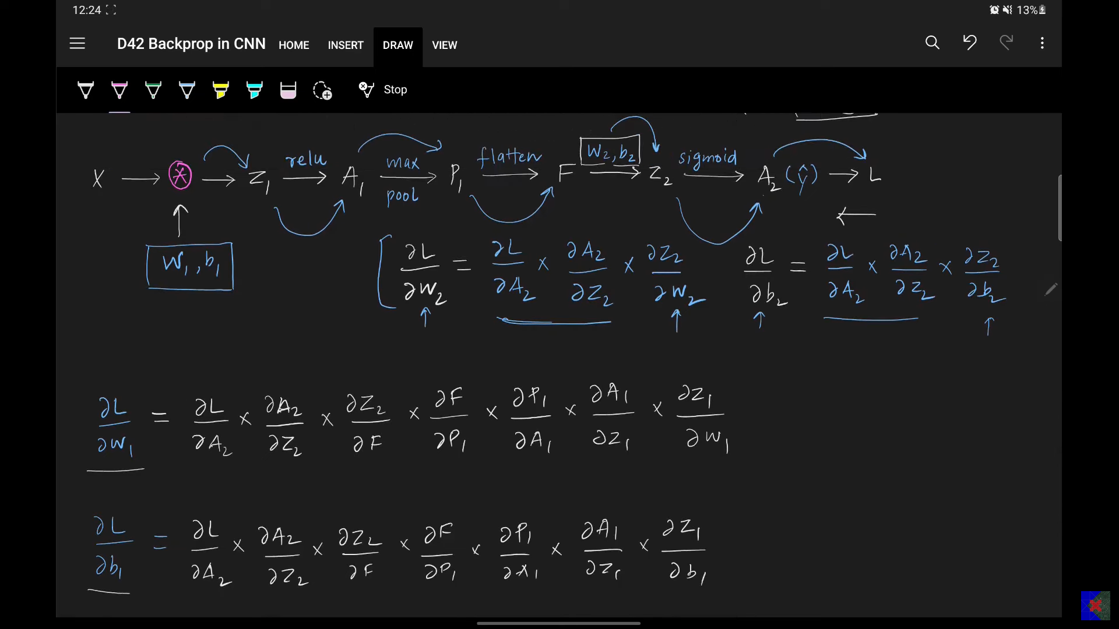



* dL/dW1 involves the chain rule through L -> A2 -> Z2 -> F -> P1 -> A1 -> Z1 -> W1.
* dL/db1 involves the chain rule through L -> A2 -> Z2 -> F -> P1 -> A1 -> Z1 -> b1.

Specifically, these derivatives require understanding backpropagation through:

* The **Flatten operation** (dF/dP1).
* The **Max Pooling operation** (dP1/dA1).
* The **Convolution operation** (dZ1/dW1).

These concepts will be covered in the **next video (Part 2)**.

### **12. Handling Mini-Batch Gradient Descent**

So far, the calculations assumed a single image. For **mini-batch gradient descent** (e.g., 32 or 64 images processed simultaneously):

* **F (Flattened output)**: Its shape changes from (4, 1) to (batch_size, 4) (e.g., (32, 4) if batch size is 32).
* **A2 (Prediction)**: Its shape changes from (1, 1) to (batch_size, 1) (e.g., (32, 1)).
* **Y (True label)**: Its shape changes to (batch_size, 1) (e.g., (32, 1)).
* **dL/db2 = A2 - Y**: This will result in a matrix of shape (batch_size, 1).
* **dL/dW2**: To get the required (1, 4) shape for W2's update, the calculation (A2 - Y) (shape (batch_size, 1)) needs to be multiplied by F.T (shape (4, batch_size)) to yield a (4, 4) result (summing across the batch for average gradient) or the transcript mentions F.T is used to transpose for the correct matrix multiplication. The resulting gradient for W2 should always be of shape (1, 4).

### **13. Conclusion and Future Steps**

* Part 1 successfully simplified and covered the **conceptual understanding and backpropagation for the neural network portion** of the CNN.
* Part 2 will delve into the backpropagation for **convolution, max pooling, and flatten layers**.
* Part 3 will apply these concepts to a **more complex CNN architecture**.
* **Recommendation**: Practice these concepts with **pen and paper** for better understanding.